Министерство науки и образования Украины
Одесская государственная академия холода

Лабораторная работа 11
по предмету: «Разработка web-систем»

Создание панели управления файлами

Выполнил:
Студент группы 351 а
Кубик Андрей
Проверила:
Швец Наталья Васильевна

files.php
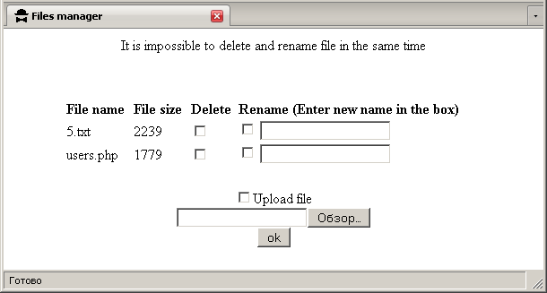

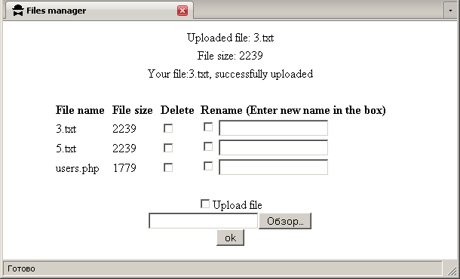

<html>
<head>
<title>Files manager</title>
</head>
<body>
<table border=0 width=80% align=center>
<?PHP
if ($_POST["Upload"])
{
print("<tr><td colspan=4 align=center>Uploaded file: $File_name</td></tr>");
print("<tr><td colspan=4 align=center>File size: $File_size</td></tr>");
if (copy($File,"USERS/$File_name"))
{
print("<tr><td colspan=4 align=center>Your file:$File_name, successfully uploaded</td></tr>");
}
else
{
print("Upload was not success");
}
unlink($File);
print("<tr><td colspan=4>&nbsp;</td></tr>");
}

if ($Delete)
{
for($i=0;$i<count($Delete);$i++)
{
if ($Delete[$i]==$Rename[$i])
{ print("<center>It is impossible to delete and rename file in the same time</center>");}
else
{
if (unlink("USERS/$Delete[$i]"))
{
print("<tr><td colspan=4 align=center> Your file, $Delete[$i], was deleted</td></tr>");
}
else
{
print("<tr><td colspan=4 align=center> Your file, $Delete[$i], cannot be deleted</td></tr>");
}
}
}
print("<tr><td colspan=4 align=center>&nbsp;</td></tr>");
}

if ($Rename)
{
for($i=0;$i<count($Rename);$i++)
{
if ($Delete[$i]==$Rename[$i])
{}
else
{
$OldName="USERS/".$Rename[$i];
$Newfile=$Rename[$i];
$New="USERS/".$NewName[$Newfile];
if (rename("$OldName","$New"))
{
print("<tr><td colspan=4 align=center> Your file, $Rename[$i], was renamed in $NewName[$Newfile]</td></tr>");
}
else
{
print("<tr><td colspan=4 align=center> Your file, $Rename[$i], cannot be renamed</td></tr>");
}
}
}
print("<tr><td colspan=4 align=center>&nbsp;</td></tr>");
}

print("<form action=\"files.php\" method=post enctype=\"multipart/form-data\">\n");
print("<tr><td><b>File name</b></td>
<td><b>File size</b></td>
<td><b>Delete</b></td>
<td><b>Rename (Enter new name in the box)</b></td></tr>");
$Open=opendir("USERS");
while ($Files=readdir($Open))
{
$FileName="USERS/".$Files;
if (is_file($FileName))
{
$Size=filesize($FileName);
print("<tr><td>$Files</td>
<td>$Size</td>
<td><input type=checkbox name=\"Delete[]\" value=\"$Files\"</td>
<td><input type=checkbox name=\"Rename[]\" value=\"$Files\">
<input type=text name=\"NewName[$Files]\"></td></tr>\n");
}
}
closedir($Open);
print("<tr><td colspan=4 align=center>&nbsp;</td></tr>");
print("<tr><td colspan=4 align=center>
<input type=checkbox name=\"Upload\" value=\"yes\">Upload file<br>
<input type=file name=\"File\" size=20><br>
<input type=submit name=\"Submit\" value=\"ok\"></td></tr>");
print("</form>");
?>
</table>
</body> </html>

